Social Mood Matcher
  - AI-Powered Social Media Caption & Hashtag Generator
Team ID : SWTID-2026-1617
Team Leader : PRIYANGA M
Team member : MUTHU ERULAYEE N
Team member : THIRISHA J
Team member : SURITHIKA B

Project Description
Social Mood Matches is a social networking platform designed to connect people who share similar emotional states or moods at a given time. The main goal of the project is to help users find companionship, support, and meaningful interactions by matching them with others who feel the same way.
In today’s fast-paced digital world, many people experience loneliness, stress, happiness, excitement, or boredom but often have no immediate social connection to share these feelings. Social Mood Matches solves this problem by allowing users to select or update their current mood and automatically find others with similar moods nearby or online.
The system uses a mood-based matching algorithm that groups users into categories such as happy, relaxed, stressed, excited, or bored. Once matched, users can interact through chat, group discussions, or shared activities like games, music sharing, or virtual meetups.
The platform also promotes mental well-being by encouraging positive conversations and providing a safe environment for users to express their feelings. Privacy and user safety features ensure that personal data and mood information remain secure.

Use Case Scenarios
Scenario 1: Food Photography with Mood Detection
Is a feature in the Social Mood Matcher project where the app detects the user’s mood using facial expressions while taking a food photo. Based on the detected mood, the system automatically enhances the food image with suitable filters, colors, and lighting. For example, if the user is happy, the photo may appear brighter and more vibrant, while
a calm mood may apply softer tones. This feature makes food photos more personalized and engaging while also helping users share their mood and dining experience on social platforms.

Scenario 2: Travel Content with Multi-Style Options
The feature in the Social Mood Matcher project where users can capture travel photos and automatically generate content in different styles. The system analyzes the location, scenery, and user mood, then applies various visual styles such as adventure, aesthetic, vintage, or cinematic. It can also suggest captions and hashtags suitable for each style. This helps users easily create attractive and personalized travel posts for social media while expressing their travel experience in different creative ways.

Scenario 3: Brand Content with Character Limiting
Is a feature in the Social Mood Matcher project that helps users create brand or promotional posts with a specific character limit. The system generates short and clear captions based on the product, brand message, and user mood, while ensuring the content stays within the required number of characters. This helps brands create concise, engaging, and platform-friendly content that is easy to share on social media.

Core Technologies
- Streamlit: Frontend framework for interactive UI and real-time content generation
- BLIP (Salesforce): Image captioning model for understanding visual content
- DistilBERT: Sentiment analysis model for mood detection
- Gemini 2.5 Flash (Optional): Enhanced AI for superior caption quality and visual intelligence
- Python-DOCX: Export captions to Word documents
- ReportLab: PDF generation with professional formatting
- Pillow (PIL): Image processing and manipulation
- Transformers (Hugging Face): AI model integration and inference

Pre-requisites
- Python 3.10+: Download from https://python.org
- Streamlit Framework: See https://docs.streamlit.io
- Google AI Studio Account (Optional): For Gemini API access at https://makersuite.google.com
- Required Python Libraries: Listed in requirements.txt
- System Requirements: 4GB+ RAM for AI model inference
- Internet Connection: For model downloads and optional Gemini API

Project Workflow
The Social Mood Matcher project follows a structured 5-milestone development process, from initial setup to production deployment. Each milestone builds upon the previous one to create a complete, production-ready application

1. Environment Setup & Configuration
- Set up project structure and file organization
- Configure environment variables and API keys
- Install dependencies and verify installations
- Test AI model connectivity (local and Gemini

2. Core Services Development
- Implement Image Sentiment Detector service
- Build Caption Generator with multiple styles
- Create Hashtag Engine with 2024 trends
- Develop Character Limiter for platform optimization
- Integrate optional Gemini service layer

3. Backend Implementation
- Design modular Flask-style architecture in Streamlit
- Create utility functions for image and text processing
- Implement session state management
- Build error handling and logging systems

4. UI Development
- Design responsive Streamlit interface
- Create image upload and preview functionality
- Build sidebar controls for style and platform selection
- Implement tabbed results display
- Add export and download features

5. Testing & Optimization
- Perform comprehensive testing across all feature
Optimize AI model performance and caching
- Validate character limiting accuracy
- Test multi-platform compatibility
- Prepare deployment configuration

MILESTONE 1: Environment Setup & Configuration

Activity 1.1: Project Structure Setup
Create the project directory structure with proper organization for services, utilities,configuration, and tests
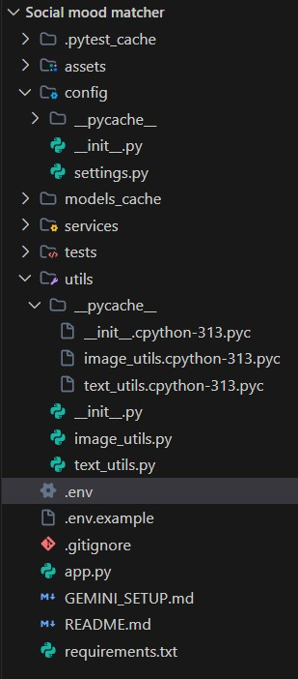

Activity 1.2: Install Dependencies
Install all required Python packages using pip. The requirements.txt includes Streamlit,
Transformers, PyTorch, Pillow, and optional Gemini API support
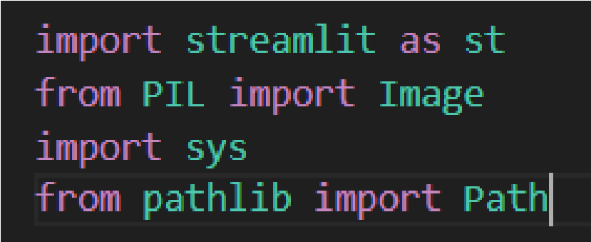

Activity 1.3: Configure Environment Variables
Set up the .env file with necessary configurations. This includes optional Gemini API key, model cache directory, and debug settings.
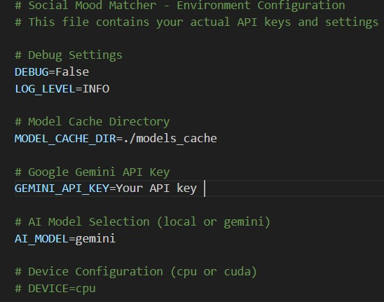

Activity 1.4: Optional Gemini Setup
- Visit Google AI Studio: https://makersuite.google.com/app/apikey

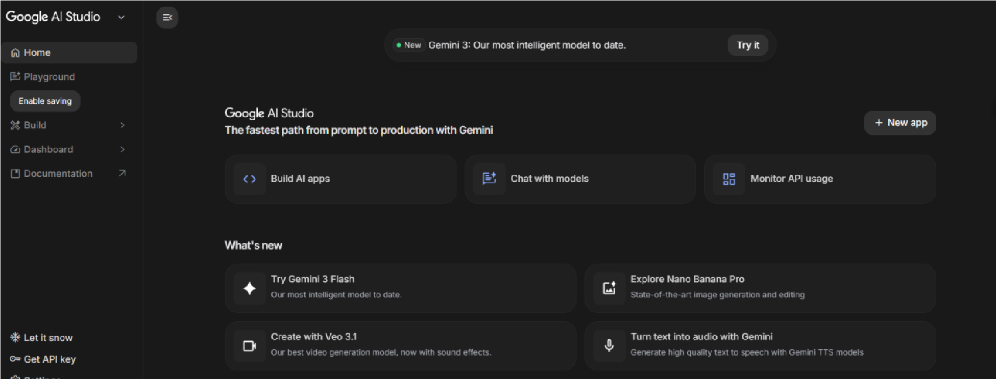
- Sign in with Google account

- Click 'Create API Key' and copy the generated key
- Add key to .env file: GEMINI_API_KEY=your_key_here

- Set AI_MODEL=gemini in .env to enable enhanced mode
- Install google-generativeai package (included in requirements.txt)
MILESTONE 2: Core Services Development

Activity 2.1: Image Sentiment Detector Service
Create the image_sentiment.py service that uses BLIP for image captioning and DistilBERT
for sentiment analysis. This service is the first step in the content generation pipeline.
Key Features:
- Load and cache BLIP image captioning model
- Load and cache DistilBERT sentiment analysis model
- Process images to extract visual descriptions
- Analyze sentiment from image captions and visual cues
- Classify into 10 mood categories (happy, cozy, aesthetic, calm, etc.)
- Detect image categories (food, travel, nature, lifestyle)
- Return confidence scores for all detected sentiments

Activity 2.2: Caption Generator Service
Develop the caption_generator.py service that creates engaging captions based on sentiment, style preferences, and image context.
Supported Styles:

Style | Characteristics | Emoji Usage
Casual | Friendly, relaxed tone | Moderate (2-3)
Aesthetic | Poetic, artistic language | Minimal (0-1)
Professional | Polished, informative | None
Playful | Fun, energetic tone | High (3-5)

Activity 2.3: Hashtag Engine Service

Build the hashtag_engine.py service that provides curated, trending hashtags organized bycategory and sentiment. Includes 2024's most popular hashtags for maximum engagement.
Hashtag Categories:
- Food: #FoodPhotography, #Foodie, #InstaFood, #FoodLover, #Delicious
•Travel: #TravelPhotography, #Wanderlust, #TravelGram, #Explore, #Adventure
•Nature: #NaturePhotography,#NatureLover, #Landscape, #Scenic, #OutdoorLife
- Lifestyle: #LifestylePhotography, #DailyLife, #Moments, #Inspiration, #Aesthetic

Activity 2.4: Character Limiter Service
Implement the character_limiter.py service that ensures all generated content fits within platform-specific character limits while maintaining message integrity

Activity 2.5: Optional Gemini Service Integration
Create the gemini_service.py for users who want enhanced AI capabilities. This service provides superior caption quality, multiple variants, and visual intelligence features.

- Enhanced sentiment detection with higher accuracy
- Multiple caption variants (aesthetic, punchy, descriptive)
- Visual intelligence: dominant colors, detected objects
- Composition tips for better photography
- More creative and contextually relevant captions

MILESTONE 3: Backend Implementation
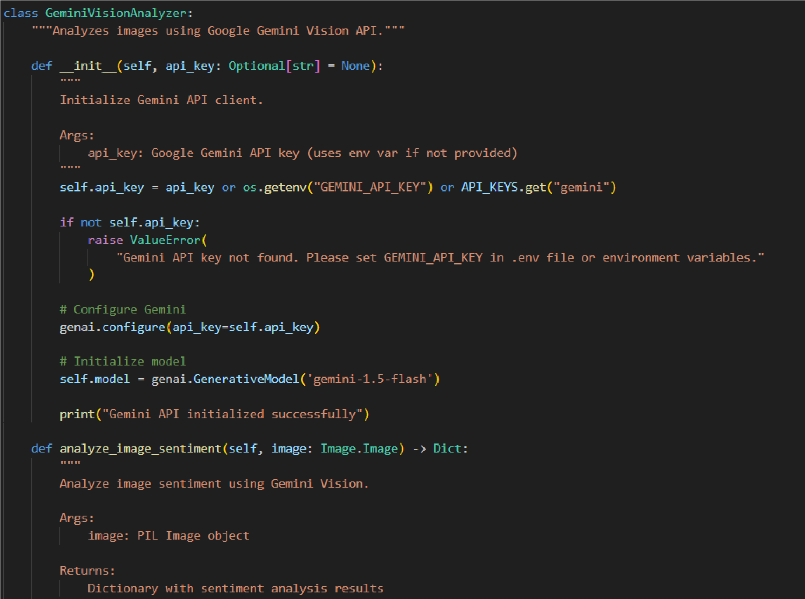

Activity 3.1: Session State Management
Implement proper Streamlit session state initialization to maintain user selections, generated content, and application state across reruns.

- generated_caption: Current generated caption
- generated_hashtags: Current hashtag list
- sentiment_result: Detected sentiment and metadata
- caption_variants: Multiple caption options (Gemini mode)
- visual_analysis: Visual intelligence data (Gemini mode)
- history: List of previous generations
- use_gemini: Toggle for Gemini vs local models
- gemini_analyzer: Cached Gemini service instance

Activity 3.2: Service Initialization and Caching
Use Streamlit's @st.cache_resource decorator to load AI models once and reuse across sessions. This significantly improves performance by avoiding repeated model loading.

- ImageSentimentDetector: BLIP and DistilBERT models (~2GB)
- CaptionGenerator: Template-based generation system
- HashtagEngine: Curated hashtag database
- CharacterLimiter: Platform rules and truncation logic
- GeminiAnalyzer (Optional): Gemini API client

Activity 3.3: Error Handling and Validation
Implement comprehensive error handling for file uploads, model inference, and API calls. Provide clear error messages and fallback mechanisms.

1.Invalid file format: Show supported formats (JPG, PNG, WEBP)

- File size too large: Display max upload size (10MB)
- Model loading failure: Show retry option or use cached models
- Gemini API error: Automatically fall back to local models
- Empty generation: Retry with adjusted parameters

Activity 3.4: Image and Text Processing Utilities
Implement utility functions in utils/ directory for common image and text operations used throughout the application.

image_utils.py: validate_image(),resize_image(),preprocess_for_model(), create_thumbnail()
text_utils.py: clean_text(), format_hashtags(), truncate_text(), smart_truncate_with_hashtags()

MILESTONE 4: UI Development

Activity 4.1: Main Layout Design
Design a two-column layout with image upload on the left and results display on the right. Include custom CSS for enhanced visual appeal.

- Header with gradient title and subtitle
- Sidebar for settings (style, platform, hashtag count, Gemini toggle)
- Left column: Image upload with preview
- Right column: Tabbed results (Content, Visual Pro, History)
- Custom color scheme matching brand (purple gradient)
- Responsive design for mobile and desktop
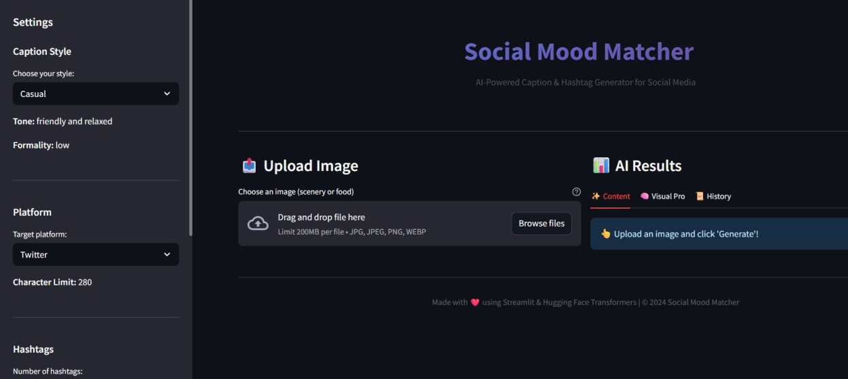

Activity 4.2: Sidebar Controls
Implement sidebar with user controls for customizing generation parameters.

- Caption Style: Select from Casual, Aesthetic, Professional, Playful
- Platform: Choose Twitter/X, Instagram, or Facebook
- Number of Hashtags: Slider from 3 to 15
- Use Gemini API: Toggle for enhanced vs local mode
- About Section: App description and features

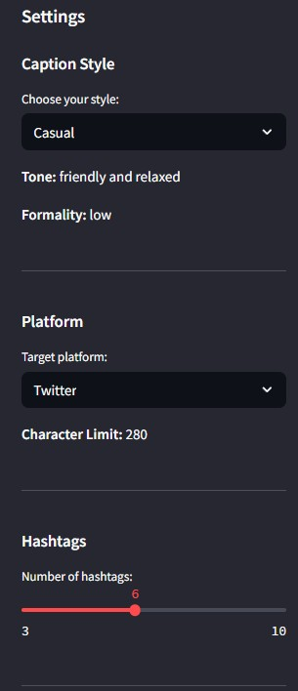

Activity 4.3: Results Display
Create tabbed interface for displaying different types of results:

Content Tab: Sentiment badge, caption variants selector (Gemini), generated caption, hashtags, character count
Visual Pro Tab: Visual intelligence (Gemini only): dominant colors, detected objects, composition tips

• History Tab: Previous 5 generations with sentiment and timestamp

Activity 4.4: Export Functionality
Add download button for exporting generated content as a text file. Content includes caption and hashtags formatted for easy copy-paste.

MILESTONE 5: Testing & Optimization
Comprehensive testing ensures reliability, accuracy, and performance. This milestone includes unit tests, integration tests, and performance optimization.

Activity 5.1: Unit Testing
Test individual components using pytest framework. Each service should have comprehensive test coverage.

- TestImageProcessor: Image validation, resizing, preprocessing
- TestTextProcessor: Text cleaning, hashtag formatting, truncation
- TestCaptionGenerator: Caption generation for all styles and sentiments
- TestHashtagEngine: Hashtag retrieval, filtering, priority-based selection
- TestCharacterLimiter: Platform limits, smart truncation, edge cases

Activity 5.2: Integration Testing
Test the complete pipeline from image upload to final content generation.

- Upload image → Sentiment detection → Caption generation → Hashtag retrieval → Character limiting
- Test with multiple image types: food, travel, nature, lifestyle
- Verify all caption styles produce appropriate outputs
- Validate character limits for all platforms
- Test Gemini fallback when API fails

Activity 5.3: Performance Optimization
Optimize application performance for faster response times and better user experience.

- Use @st.cache_resource for model loading (prevents reloading)
- Implement image resizing before model inference (faster processing)
- Add loading spinners during AI operations (better UX)
- Cache Gemini API client to avoid repeated initialization
- Optimize session state updates to minimize reruns

Conclusion
The Social Mood Matches project demonstrates how technology can be used to strengthen social connections by matching people based on their current emotional state. By allowing users to share their moods and interact with others who feel the same way, the platform creates a supportive and engaging online community.
This system helps reduce feelings of loneliness, encourages open communication, and promotes positive social interaction. The mood-based matching feature enables users to find understanding companions quickly, making conversations more meaningful and relatable.
Overall, Social Mood Matches provides an innovative approach to social networking by focusing on emotional connection rather than just profiles or interests. With further improvements such as advanced mood analysis and enhanced security features, the platform has the potential to become a valuable tool for building stronger and healthier online communities.

